**Ectotherms and Endotherms**

271

**K ey Id ea:** The thermal classification of animals is based on their source of body heat. In endotherms, the source of body heat is metabolic activity. In ectotherms, it is the environment. The process of controlling body temperature is called **thermoregulation.** For many years, animals were classified as either **homeotherms** (= constant body temperature) or

**poikilotherms** (= variable body temperature). A more recent thermal classification of animals is based on the source of the body heat. If it is largely from the environment, the animal is **ectothermic .** If it is largely from metabolic activity, the animal is **endothermic.** In reality, many animals still fall somewhere between the two extremes.

# How Body Temperature Varies

Aquatic invertebrates like jellyfish are Tuna and some of the larger sharks Hibernating rodents andbatslet their Most birds and mammals maintain true poikilotherms: their temperature can maintain body temperatures up body temperature drop to well below a body temperature that varies less is the same as the environment. to14°C above the water temperature. what is typical for most mammals. than2' C: theyare truehomeotherms.

*Increasingly homeothermic*

**Poikilothermic**

Body temperature varies with the environmental temperature. Traditionally includes all animals other than birds and mammals, but many reptiles, some large insects and somel arge fish are not true poikilotherms because they may maintain body temperatures that are different from the surrounding environment.

**Homeothermjc**

Body temperature remains almost constant despite environmental fluctuations.Traditionally includes birds and mammals, which typically maintain body temperatures close to 37-38°C.Many reptiles are partially homeothermic and achieve often quite constant body temperatures through behavioural mechanisms.

# Source of Body Heat

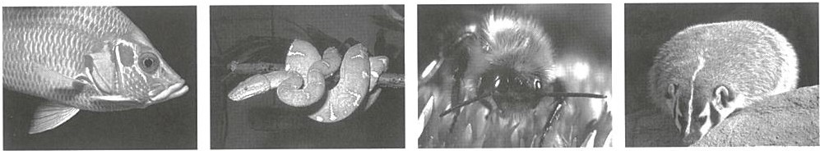

With a few exceptions, most fish are ectothermic. Unlike many reptiles they donot usually thermoregulate.

Snakes use heat energy from the environment to increase their body temperature for activity.

Somelarge insects like bumblebees may raise their temperature for short periods through muscular activity.

Mammals (andbirds) achieve high body temperature through metabolic activity andreduction of heat losses.

**Ectothermic**

*Increasingly endothermic*

**Endothermic**

Ectotherms depend on the environment for their heat energy.The term ectotherm is often equated with poikilotherm, although they are not the same. Poikilotherms are also ectotherms but many ectotherms may regulate body temperature (often within narrow limits) by changing their behaviour (e.g. snakes and lizards).

Endotherms rely largely on metabolic activity for their heat energy. Since they usually maintain a constant body temperature, most endotherms are also homeotherms. As well as birds and mammals, some fast swimming fish, like tuna, and some large insects may also use muscular activity to maintain a high body temperature.

**Daily temperature variations in ectotherms and endotherms** 45

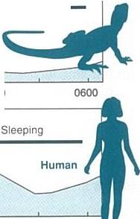

**Ectotherm :** Diurnal lizard (top right)

Active Emergence Retreat and nocturnal inactivity

Body temperature is regulated by 35 Diurnal **desert**

behaviour so that it does not rise above

40°C. Basking increases heat uptake

I!!

li zard

Retreat

from the sun. Activity occurs when body temperature is high. Underground burrows are used for retreat.

e::> 25 0600 1200 1800 2400

"0.'

E

ll! 37

**Endotherm:** Human (bottom right) >,

Body temperature fluctuates within

Meals D D D

Exercise

narrow limits over a 24 hour period. 36

Exercise and eating increase body temperature for a short time.Body

temperature falls during rest and is 35

partly controlled by an internal rhythm.

0600 1200 1800 2400 0600

Time of Day

272

1. (a) What is a homeothermic endotherm? _ _ _ _ _ _ _ _ _ _ _ _ _ _ _ _ _ _ _ _ _ _ _ _ _ _ _

(b) Why is "poikilotherm" not a good term for classifying many terrestrial lizards and snakes? _ _ _ _ _ _ _ _ _ _

1. Ectotherms will often maintain high, relatively constant body temperatures for periods in spite of environmental fluctuations, yet they also tolerate marked declines in body temperature to levels lower than are tolerated by endotherms.
   1. What is the advantage of letting body temperature fluctuate with the environment (particularly at low temperature)?
   2. Why is ectothermy regarded as an adaptation to low or variable food supplies? _ _ _ _ _ _ _ _ _ _ _ _ _ _
2. Some endotherms do not alwaysmaintain a high body temperature. Some, such as small rodents, allow their body temperatures to fall during hibernation. What might be the advantage of this behaviour?

::,

|  |  |  |
| --- | --- | --- |
|  | 40 | Homeothermic endotherm |
| (.)  0 | 30 |  |
| l!! |  |  |
| t§  Q)  a. | 20 |  |
| *2*  >,  'C |  |  |
| CD | 10 |  |

E

0

a,"

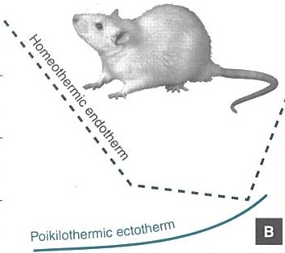V)

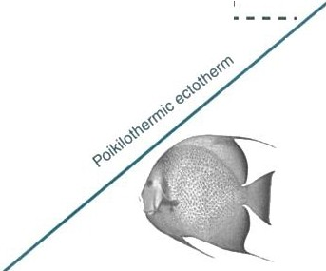

a

h

C

8

C

Q)

j;!

X

0

10 20 30 40 10 20 30 40

Environmental temperature / •c Environmental temperature / •c

1. The two graphs above illustrate the differences in temperature regulation between a homeothermic endotherm and a poikilothermicectotherm (such as a fish). Graph A shows change in body temperature with environmental temperature. Graph 8 shows change in oxygen consumption with environmentaltemperature. Use the graphs to answer the following:
   1. How do ectotherms and endotherms differ in their response to changes in environmental temperature (graph A):
   2. Why would a poikilothermic ectotherm (no behavioural regulation of temperature) be restricted to environments where temperatures were below about 40°C:
   3. In graph B, state the optimum temperature range for an endotherm:
   4. For an endotherm, the energetic costs of temperature regulation (as measured by oxygen consumption) increase markedly below about 15°C and above 35°C. Explain why this is the case:
   5. For an ectotherm (Graph 8), energy costs increase steadily as environmental temperature increases. Explain why: